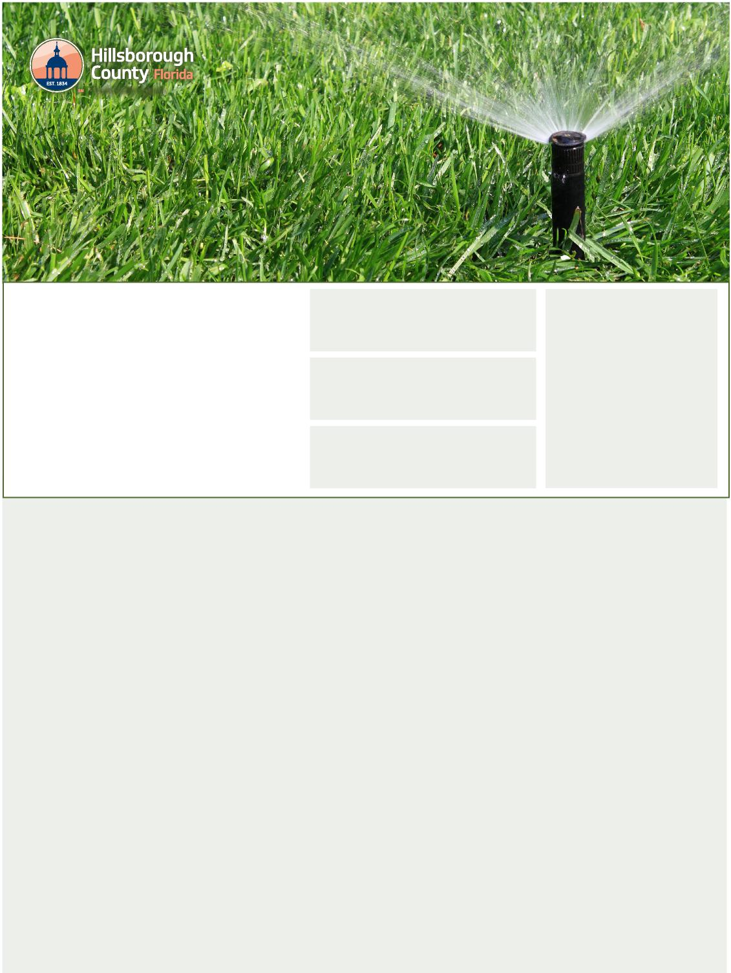

These restrictions apply to all residents - not just customers of Public Utilities - and most water sources, including private wells, and ponds or lakes that are used as alternate irrigation supplies. **Reclaimed water customers may irrigate any day of the week before 10 a.m. OR after 4 p.m.**, although these customers are encouraged to use only what is needed.

**Who do these water restrictions apply to?**

* Odd numbered addresses, locations with no address, and locations with mixed addresses on Monday, Wednesday, and/or Saturday
* All watering of new sod and landscaping must be done
* An irrigation system zone can only be operated if the new sod or plant material covers at least 50 percent of that zone

either before 8 a.m. OR after 6 p.m.

Code Enforcement

**Guide to**

**Outdoor Watering**

**Find Your Watering Days**

This schedule is for watering established
  
lawns and landscaping
  
in unincorporated Hillsborough County.
  
All watering must be done in one
  
of the allowed watering periods
  
**on your designated day:
  
Between 12:01 - 8 a.m.
  
OR 6 p.m. - 12 a.m. (midnight)**

Addresses ending in

**0, 1, 2 and 3**

**Mondays and/or Thursdays**

Addresses ending in

**4, 5 and 6**

**Tuesdays and/or Fridays**

Addresses ending in

**7, 8 and 9**

**Wednesdays and/or Saturdays**

Locations with

**no address**

(common areas) and
  
locations with

**mixed addresses**

(such as office complexes
  
and shopping centers)
  
**Wednesdays and/or
  
Saturdays**

**Hand-Watering**

**Rain-Sensing Devices Required**

Hand-watering and low-volume irrigation of plant material other than lawns or turfgrass may be done on any day and at any time.

**Chemical Applications**

All automatic irrigation systems must have an operable automatic rain-sensing device or switch, which overrides the irrigation cycle of the automatic irrigation system when adequate rainfall occurs.

New sod and landscaping may be watered before **8 a.m. OR after 6 p.m. on any day for the first 30 days**. On days 31-60, new sod and landscaping may be watered approximately every other day:

Irrigation for the purpose of watering-in fertilizers, insecticides, fungicides, and herbicides must be done during allowable watering days and times, unless permitted under exceptions in Sec. 111-7(d).

**New Sod and Landscaping**

**For More Information**

* For complete information on these and other water rules in unincorporated Hillsborough County, as well as links to information from the cities of Tampa, Plant City, and Temple Terrace, visit [**HCFLGov.net/WaterRestrictions**](http://HCFLGov.net/WaterRestrictions.).
* For a recorded message about the restrictions or questions for the Water Conservation Team, call (813) 663-3295.

Sunday

Southwest Florida Water Management District.

* Even-numbered addresses on Tuesday, Thursday, and/or

Hillsborough County water restrictions are mandated by the

[HCFLGov.net](http://HCFLGov.net)