TEMPORARY DAYS AND HOURS IN SOUTH HILLSBOROUGH COUNTY THROUGH DEC. 31, 2022

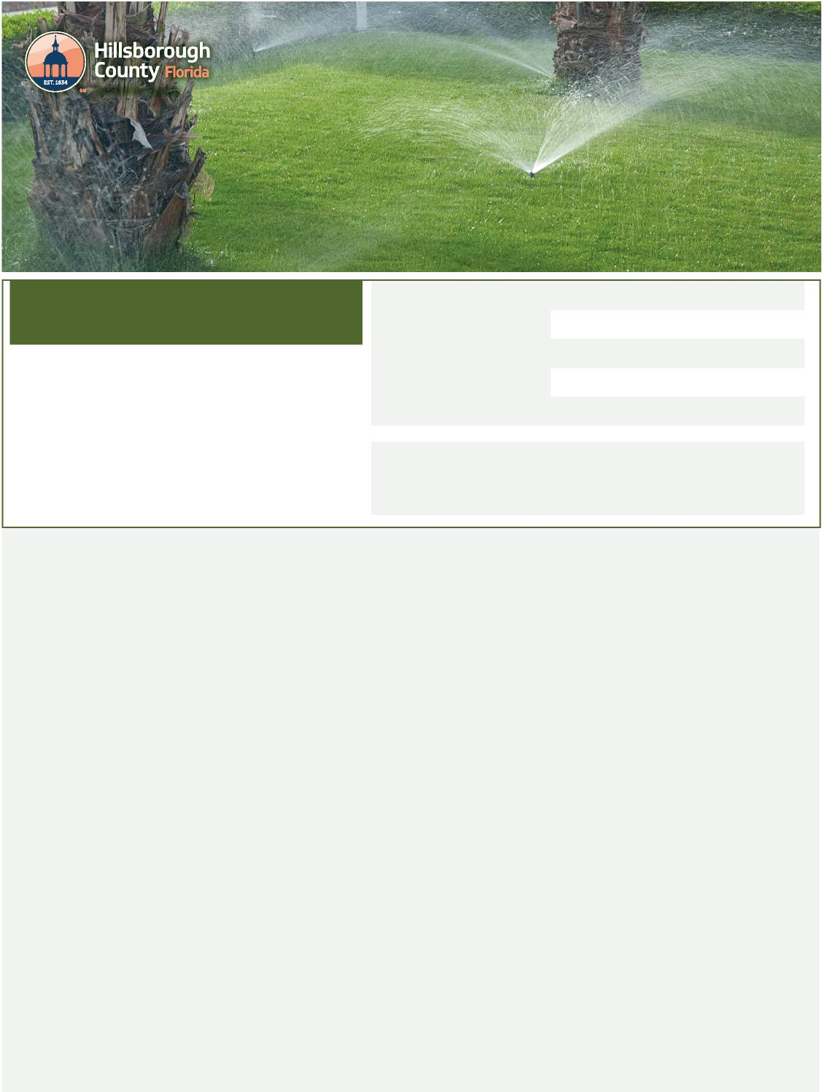
Code Enforcement
Hillsborough County through Dec. 31, 2022
This schedule is for watering established
lawns and landscaping in unincorporated
Hillsborough County. All watering must
be done in one of the allowed watering
periods on your designated day:
Between 8:30 a.m. - 12 p.m. (noon)
OR 6 p.m. - 12 a.m. (midnight)
Temporary Days and Hours in South
Find Your Watering Days
Outdoor Watering
Guide to
Locations with no address and locations with mixed addresses (such as office complexes and shopping centers) on Saturdays
Addresses ending in
0 or 1 on Mondays
2 or 3 on Tuesdays
4 or 5 on Wednesdays
6 or 7 on Thursdays
8 or 9 on Fridays
Who do these water restrictions apply to?
These restrictions apply to all within the South County variance area using potable (drinking) water supplied by Hillsborough County Public Utilities for irrigation. Other water sources, including private wells, and ponds or lakes that are used as alternate irrigation supplies continue to follow year-round water restrictions. Reclaimed water customers may irrigate any day of the week before 10 a.m. or after 4 p.m., although these customers are encouraged to use only what is needed.
Hand-Watering
Hand-watering and low-volume irrigation of plant material other than lawns or turfgrass may be done on any day and at any time.
Chemical Applications
Irrigation for the purpose of watering-in fertilizers, insecticides, fungicides, and herbicides must be done during allowable watering days and times, unless permitted under exceptions in Sec. 111-7(d).
Rain-Sensing Devices Required
All automatic irrigation systems must have an operable automatic rain-sensing device or switch, which overrides the irrigation cycle of the automatic irrigation system when adequate rainfall occurs.
New Sod and Landscaping
New sod and landscaping may be watered either between 8:30 a.m. and noon OR after 6 p.m. on any day for the first 30 days. On days 31-60, new sod and landscaping may be watered approximately every other day:
- Even-numbered addresses on Tuesday, Thursday,
and/or Sunday
- Odd numbered addresses, locations with no address, and locations with mixed addresses on Monday, Wednesday, and/or Saturday
- All watering of new sod and landscaping must be done
either between 8:30 a.m. and noon OR after 6 p.m.
- An irrigation system zone can only be operated if the new sod or plant material covers at least 50 percent of that zone
For More Information
- For complete information on these and other water rules in unincorporated Hillsborough County, as well as links to information from the cities of Tampa, Plant City, and Temple Terrace, visit HCFLGov.net/WaterRestrictions.
- For a recorded message about the restrictions or questions for the Water Conservation Team, call (813) 663-3295.
Hillsborough County water restrictions are mandated by the Southwest Florida Water Management District.
HCFLGov.net

