***Volume 19 – Issue 6***

***2021 Board of Directors:***

**President – Sam Gray**

**Vice President – Max Saus**

**Secretary – Ron Bowman**

**Treasurer – Cyndie Smith**

**Dir. at Large – Mike Flanagan**

an02097_

*Lake Heron is a welcoming, caring, vibrant and well managed community we call home.*

|  |
| --- |
| ***LAKE HERON ANNUAL***  ***Community YARD SALE***  ***Sat. Nov. 13th 2021***  ***7:30am-2:30pm***  Or until you run out of STUFF or STEAM!  **Please Drop off $2.00 in a SEALED ENVELOPE With your NAME, ADDRESS, and PHONE #**  **If you plan to PARTICIPATE in ADVANCE** to:  Linn Torres 813-240-4398  1713 Lake Heron Drive…Leave in front porch  *\*\*****THIS WILL ENSURE\*\****  **A sign is made for your STREET as well as signs put up on Osprey, 41 & 54. All you have to do is get your things ready for the SALE!**  **\*\*\*\*\*\*\*\*\*\*\*\*\*\*\*\*\*\*\*\*\*\*\*\*\*\***  Email your articles for the next issue to  Dee Ryder at **Dee\_Ryder@Verizon.net**  put ***"For The Banner"*** in the Subject line *Please* …  Only emailed items will be accepted.  ***October 2021 Banner Deadline is September 26, 2021*** |

ite

Lake Heron HOA does not recommend nor endorse any advertisement printed in the Banner.



christmd

***September***

***Board Meeting will be on***

***Sept 13, 2021 at***

***6:30 PM on ZOOM. This is a permanent time change***

***President’s Corner***

Reminder: September 13, 2021 Board Meeting at 6:30 PM will be a Virtual Meeting on Zoom.

Fall arrives Wednesday, September 22, 2021 for this tempest tossed year. Let’s hope events quiet down and we can look forward to pumpkins, hob goblins, cider, and turkey dinners.

I continue to state that LH is changing. Many new residents have appeared, we have had to say goodbye to previous long termers, and with these changes there arises many questions and concerns of how LH operates. What are the rules, protocols, resident’s responsibilities, and the simple do’s and don’ts.

LH is an HOA (Home Owners Association) governed by a Board of Five resident elected directors charged with acting for the benefit of the entire community. Florida statute states that terms should be limited to eight years maximum. We empower committees to provide suggestions, proposals, and insight to the Board for their decision considerations. Board and Committee members are all volunteer positions with their love of community their only compensation. LH employs a management company UPI (Universal Property Inc.) to manage our vendor services, provide legal and procedural guidance, and maintain our financial / accounting records. LH has an operating budget to pay for the care of community grounds, maintenance expenses, tree trimming, the pool / courts upkeep, and other essential items. LH has reserve fund accounts to provide financing for those long term replacement costs such as roads, siding, roofs, etc. Your LH resident’s HOA assessment is the revenue that pays for the Operating and Reserve budgets. As maintenance costs increase, more services become needed or as replacement costs of item increases the HOA dues may increase. Costs are generally minimized by several factors: conservative and wise use of resources (funds), cost reductions, being proactive with replacements, considering if items are wants or needs, detailed specifications to vendors, and to some extent competitive bidding of projects. Costs are also controlled by residents following LH guidelines and also maintaining their property to benefit themselves and the community as a whole.

Resident voices, input, and help are paramount in managing our HOA. Lack of volunteers can cause the need to hire more services thus increasing costs. We need committees to be an active and responsible part of the LH Management team. LH needs doers, writers, contributors, thinkers, and those who will help establish procedures, practices, and rules so that all know established responsibilities and expectations. Committee and members must be Board approved, should have a written charter defining roles and limits, and consists of at least three members. LH needs new committees and volunteer additions to the Board, Lake, Parking, Social, Pool, Grounds, IT, Document writing / editing, Recreation Courts, Rules, Electronic Media, Communications, etc.

To all Residents, Lake Heron is your chosen home. Your voice, actions, and support are needed. Each and every resident through your action or inaction will determine what Lake Heron will be today, tomorrow, and in the future.

Stay healthy and safe,

*~Sam Gray*

Email: [LH.President99@gmail.com](mailto:LH.President99@gmail.com)

PH: 607-738-2137

***Note:*** To obtain an email copy of the LH Meeting agenda and to receive email of pertinent information or notifications between Banner printings, I need interested residents to send me an email stating their approval to receive email agendas and pertinent notifications. Your email will not be publicly shared. Send the email to: [LH.President99@gmail.com](mailto:LH.President99@gmail.com)

Rev: 08/23/21

LAKE HERON HOMEOWNERS ASSOCIATION, INC.

BOARD OF DIRECTORS MEETING

September 13, 2021 / 6:30 P.M.

AGENDA

1. **Residents Discussion and Comments from the floor**
2. **Call to Order**
3. Establish Quorum –Roll Call
4. Proof of Due Notice Posted: 48 Hr. Secretary
5. Reading of Minutes – Secretary
6. **Committee Reports**
   1. Finance
   2. Architectural Control
   3. Grounds
   4. Club House – Electrical repair status
   5. RV Parking
   6. The Park Team
   7. Parking Enforcement
   8. Social Committee
7. **Old / Unfinished Business:**
8. Reconfirm votes on the previous motions:
9. Club House Closure: A motion was presented that the Clubhouse remain closed to rentals and functions until future notice (possibly Nov. / Dec.) due to Covid-19 variant and the need to complete major electrical repairs. (vote passed 5 yea / 0 nay)
10. LH Peacocks: Motion presented to approve the service agreement with TRUTECH for the removal of Peacocks starting sometime in July 2021 at and approximate cost of $ 5,278.00 for the first year. (vote failed 2 yea / 3 nay) The initial proposal was withdrawn after this vote was taken.
11. Starting October, Green Bandit lawn service will service Lake Heron every other week.
12. **New Business:**
13. Motion that $36,000 of prior retained earnings be transferred to the road reserve fund.
14. LH road conditions, reserve funds, and start date to resurface. Now projected at mid-2023.
15. Board members list of 2022 projects for budget consideration.
16. Need to establish a list of committees and solicit additional volunteers: (ie. Information Technology, Lake Committee, Rules Committee, etc.)

C. Possible methods of providing better communication between board, management co., and residents.

9. **Adjournment**

*Note: Next Zoom Meeting October 11th, 2021 at 6:30 PM*

Note: First part of meeting residents and committee members may address a topic for up to 3 minutes. Speakers must refrain from entering into a debate or group interaction. Board members may return only pertinent brief comments. Then Committee reports will be given as a report. Moving to the board members portion, all residents and committee members will be muted to provide board members discussion and voting.

***Some Useful Tips***

Our homes in Lake Heron are between 25 and 22 years old and several maintenance issues come up in that length of time. In the attic the firewall between units consists of sheets of drywall nailed to the studs. This is standard and meets building codes, but the constant heating and cooling extremes in the attic can cause the nails to work loose. Occasionally parts of the drywall come completely loose and fall. The drywall needs to be securely refastened in order to provide a firewall between units. Any handyman can do this, but it is your responsibility to check your attic, or have someone do it for you. This is not an association responsibility and you should check your drywall at least every few years until, or unless, you have it refastened. Once it is refastened it should be good for another 20 years.

The other maintenance issue is the drier vent on your clothes drier. They do plug up with lint over the years even though you keep the lint screen clean. After twenty-two years I had ours professionally cleaned. It was 70% plugged ! That meant it was wasting electricity, running longer than it should to dry a load of clothes. I’ll save back the money I spent on professional cleaning in just a few years by using less electricity.

*~John Copeland*

***Slowing Down***

I volunteered to take over Clubhouse rental duties and distribution of pool keys back in 2005. The job grew and grew as time went by. From checking the pool every other day to buying furniture for the dining room of the clubhouse, were just some of the items that came along. Now I find I need to slow down and turn over the duties to the next volunteer, so at the end of this month I will be turning over Clubhouse rentals to Angela Hester, of University Properties, along with the Pool key distribution duties. Hopefully she’ll find someone to fill in for me soon. It’s been my pleasure, most of the time, to serve my community and neighbors. To keep our community in top shape, we need some of our new neighbors to volunteer for the many jobs that help keep the monthly HOA dues low and the neighborhood looking great. See ya around. *~~~Ed Martinell*

***New Lighting in Clubhouse Restrooms***

The old lighting system in both restrooms needed an upgrade. Additional LED lights have been added over the stalls and the advantage is both more illumination, longer life of the lights and lower electric cost. The original light switches were timers intended to turn off the lights after sufficient time had gone by, but with time they failed to function properly. The result was that sometimes the lights would remain on for hours, even days. Our electrical contractor suggested a combination sensor triggered by either motion or heat. That sensor is mounted in the ceiling where it can sense motion or heat anywhere in the restroom, including at the entrance. The new sensor requires getting used to one design issue. A combination sensor requires a 5 second delay after it senses motion/heat before it turns the lights on. When first opening the door it may seem that the lights don’t work, but in 5 seconds the lights will turn on. You may wish to hold the door open until the lights go on. They are set to stay on for 15 minutes but if they turn off while someone is still in the room any motion, such as waiving an arm, will turn them back on.

***A Letter from John***

2021 is my last year of service to Lake Heron. After twenty-three years we deserve a break from each other. I take some personal pride in the way the property looks after twenty-six years of existence, and in the fact that we our reserves are fully funded and we are financially sound. That is rare in managed communities.

I’d like to leave the community with a few Best Practices to guide you into the future:

1) Three is the magic number; committee members, competitive bids, director terms, etc.

2) The goal of competitive bids should be better service, never lower costs. A strategy of constantly lowering costs will lead to destruction of real estate values and what made Lake Heron attractive to you in the first place.

3) Communication & transparency, communication & transparency, communication & transparency.

4) If someone knocks on your door and asks to talk to you about helping the community out, invite them in and listen to the opportunity they offer. It isn’t often in life someone recognizes that you have something to bring to the table that will benefit your community. I promise you – it will benefit you as well!

*Sincerely, John W. Copeland*

***Field Of Dreams***

When I moved to Lake Heron in 2001 it was quite a vibrant community. A lot of the original owners still lived here and were involved in most of the activities that were available. They did their best to make this one of the best communities to live in. It still is, but!!! As time goes along most of the original owners are long gone. That only leaves a few of us left to do what we can for the community. Over five years ago it was hard to find enough volunteers to fill all the openings in the community. The work of a volunteer does not require special skills and very little of your time. Now the interesting part. If we cannot get enough volunteers, then Lake Heron will have to hire an on-site manager to fill in for the needed work to be done. That will cost us at least $30,000 per year at a cost of more than $15 per month added to our assessment. Now the reason for the title of this article, "Field of Dreams". Too many of us prefer to watch in the cornfield rather than step up to the plate and help us just a little bit.

I know there are some bad viruses out there right now. You can call me at 813- 948-4538 and we can discuss what areas you would like to help the community in the future. Looking forward to your call.

*~Max Saus*



***Get Ready to Sell Your Stuff and Shop at Your Neighbors!!!!***

Note: This is a representative Director and Committee Member Application form. For those interested is stepping up to support our Lake Heron Community. Complete with your interests and forward to:

Angela Hester c/o Universal Properties Inc. or Sam Gray – President for transferring to UPI

**LAKE HERON HOMEOWNERS ASSOCIATION, INC.**

**WRITTEN NOTICE OF DESIRE TO BE A CANDIDATE FOR DIRECTOR**

I, \_\_\_\_\_\_\_\_\_\_\_\_\_\_\_\_\_\_\_\_\_\_\_\_\_\_\_\_\_\_\_\_\_, hereby request that my name be included on the ballot as a Candidate for the Board of Directors.

LH Address \_\_\_\_\_\_\_\_\_\_\_\_\_\_\_\_\_\_\_\_\_\_\_\_\_\_\_\_\_\_\_\_\_\_\_\_\_\_\_\_\_\_\_\_

Signature: \_\_\_\_\_\_\_\_\_\_\_\_\_\_\_\_\_\_\_\_\_\_\_\_\_\_\_\_\_\_\_\_\_\_\_\_\_\_\_\_\_\_\_\_ Date: \_\_\_\_\_\_\_\_\_\_\_\_\_\_\_\_\_\_\_

Please email to manager or mail or fax to Universal Properties Inc. 3018 N. U.S. Highway 301, Suite 950, Tampa, Florida 33169. Fax: (813) 980 -2233

\_\_\_\_\_\_\_\_\_\_\_\_\_\_\_\_\_\_\_\_\_\_\_\_\_\_\_\_\_\_\_\_\_\_\_\_\_\_\_\_\_\_\_\_\_\_\_\_\_\_\_\_\_\_\_\_\_\_\_\_\_\_\_\_\_\_\_\_\_\_\_\_\_\_\_\_\_\_\_\_\_\_\_\_

**CERTIFCATION REQUIRED Pursuant to Florida Statute 720.3033**

Lake Heron Homeowners Association Inc.

I, (Print Name) \_\_\_\_\_\_\_\_\_\_\_\_\_\_\_\_\_\_\_\_\_\_\_\_\_\_\_\_\_\_\_\_\_\_ certify to the Secretary of the association that I have read the declaration of covenants, articles of incorporation, bylaws and current written policies. I agree to work to uphold our documents and policies to the best of my abilities. Furthermore, I will faithfully discharge my fiduciary responsibility to the association’s members.

Name \_\_\_\_\_\_\_\_\_\_\_\_\_\_\_\_\_\_\_\_\_\_\_\_\_\_\_\_\_\_\_\_\_\_\_ Date: \_\_\_\_\_\_\_\_\_\_\_\_\_\_\_\_\_

Signature: \_\_\_\_\_\_\_\_\_\_\_\_\_\_\_\_\_\_\_\_\_\_\_\_\_\_\_\_\_\_\_\_\_\_\_\_

***Must be received no later than December 31, 2021***

\_\_\_\_\_\_\_\_\_\_\_\_\_\_\_\_\_\_\_\_\_\_\_\_\_\_\_\_\_\_\_\_\_\_\_\_\_\_\_\_\_\_\_\_\_\_\_\_\_\_\_\_\_\_\_\_\_\_\_\_\_\_\_\_\_\_\_\_\_\_\_\_\_\_\_\_\_\_\_\_\_\_\_\_\_

**Application for Lake Heron Homeowners Association Committee Member or Committee Formation**

I, \_\_\_\_\_\_\_\_\_\_\_\_\_\_\_\_\_\_\_\_\_\_\_\_\_\_\_\_\_\_\_\_\_\_\_\_, hereby request the LH Board to consider my name for membership on the following committee (\_\_\_\_\_\_\_\_\_\_\_\_\_\_\_\_\_\_\_\_\_\_\_\_\_\_\_\_\_\_\_\_\_). And/or I request consideration by the Board to form the following committee. (\_\_\_\_\_\_\_\_\_\_\_\_\_\_\_\_\_\_\_\_\_\_\_\_\_\_\_\_\_).

These applications for Committee membership or Committee formation should be emailed to Angela Hester @ UPI or Sam Gray a minimum of one week prior to any scheduled Board meeting for Board consideration and meeting inclusion.

***Garbage and Recycling***

If you recycle, you ***CAN NOT*** use any bags.

You ***MUST*** use a dedicated container (tub or can).

***The Recycling will be picked up every Wednesday,***

***usually before 7am***

The truck crews will pass by any container that has plastic bags.

We see more and more bags being left out for curbside pick up, and those bags are being ignored.

Your recycle container should have a “Recycle Sticker” on it.

The stickers can be obtained by calling **727-856-4539**.

***Reminder – When Home or Away***

You can still get The Banner and keep up with Lake Heron news by accessing the Lake Heron website.

Access to Lake Heron Web Page

1. Type into your internet search page **“univprop.com”**
2. Locate **“Association Pages”** in the contents list in the left border
3. Lake Heron’s number is 4350. Put your mouse in the number list and scroll down to 4350 and click on it.
4. The website will now open with the calendar of events for the clubhouse.  To reach other pages just scroll down (or Page Down).

On our web page you’ll find copies of The Banner, Board Minutes, Directors and committee Chairpersons. Our standardized forms in printable copies are on the web page.

***Information To Set Up Zoom For Lake Heron Meetings***

In order to attend the Zoom meeting you will need to download the [Zoom.us](http://zoom.us/) app by going to [www.zoom.us/download](http://www.zoom.us/download) and click to sign up. You will need a camera and a microphone on your computer in order to participate. On the scheduled date and time of the meeting you would click on join a meeting and you will be asked for the following information in order to be a part of the meeting:

**MEETING ID: 219 022 5906    /     PASSCODE:  2020**

***RECYCLING BIN***

The Lake Heron recycling bin has been removed.  You can add paper and cardboard to you curbside recycling pickup every Wednesday of each month.

Thank you.

***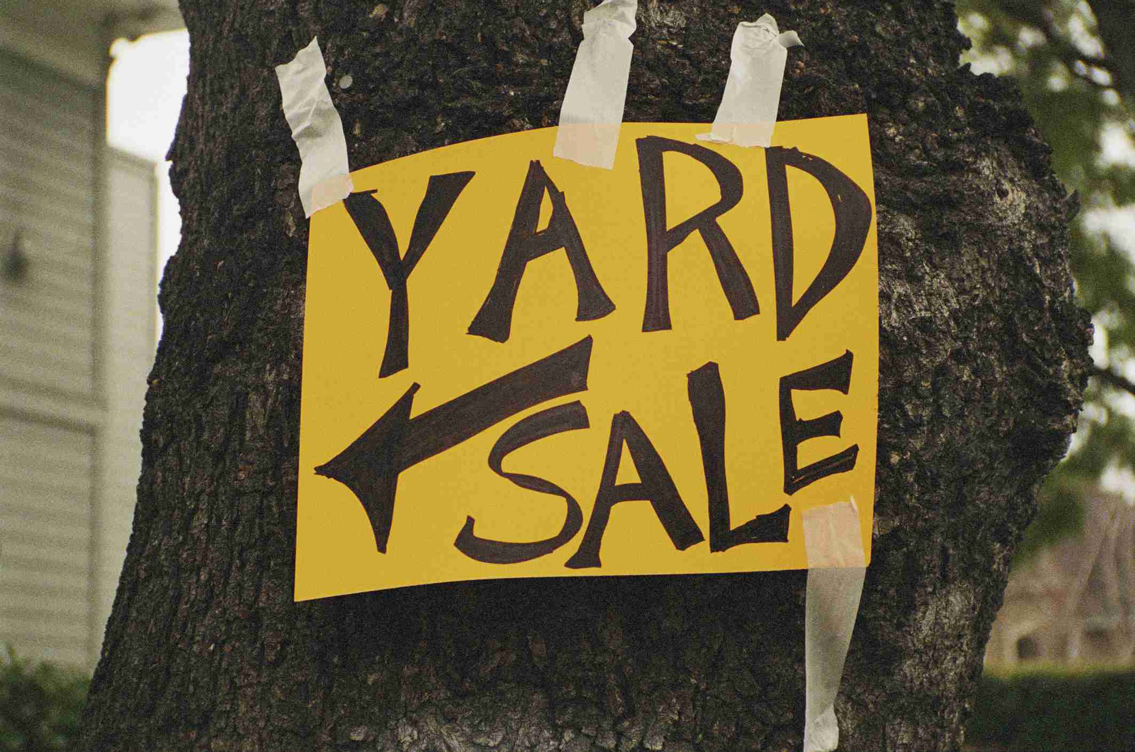***

***HOA Dues***

Homeowners can now pay association dues with credit cards if they wish.

Simply go to **www.univprop.com** and click on pay credit card payment and follow the link.

Visa, Master Card, American Express and Discover Card may be used.

If the homeowner does use the credit card there is a 5% convenience fee the homeowner is charged.

***Lake Heron Contact Information*:**

***Property Manager*** - Angela Hester

University Properties Inc. 813-980-1000

or email her at... ahester@univprop.com

***Website* -** Univprop.com - HOA# "4350"

***Volunteers* *Name***

**Board (President) Sam Gray**

**Board (VP) Max Saus**

**Board (Secretary) Ron Bowman**

**Board (Treasurer) Cyndie Smith**

**Board (Director A.L.) Mike Flanagan**

**Park**

Ron & Lori Bowman Kathy & Sam Gray

Pam Schwebl Ruth Copeland

Don Bushkie Linn Torres

Bonnie Mikulla Maxine Pickert

Susan Hoelseggen Lee Carter

Pam Kelly Sheila King

**Social Committee**

Sheryl and Ron Spencer Cyndie and Bram Smith

**Newsletter Delivery**

Vickie Morris Beverly Patterson

Betsy Nehr Sherry Williamson

John Copeland Maria Saldarriaga

Hoke Cash

**Newsletter** Dee Ryder

**Grounds**

Don Bushkie Ruth Copeland (Irrigation)

**Architectural Control** Pam Kelley (Chairperson)

Matt Boisvert

Rachel Powers

Bill Prall

**Finance**

Kathy Gray Cyndie Smith

John Copeland

**RV Park**

Max Saus (Chairperson) Larry Kelly   
Hoke Cash

**Community Center**

Ed Martinell

John Copeland

**Wright Termite & Pest Control - 813-948-0229**