***Volume 19 – Issue 8***

***2021 Board of Directors:***

**President – Sam Gray**

**Vice President – Max Saus**

**Secretary – Ron Bowman**

**Treasurer – Cyndie Smith**

**Dir. at Large – Mike Flanagan**

an02097_

*Lake Heron is a welcoming, caring, vibrant and well managed community we call home.*

|  |
| --- |
| ***LAKE HERON ANNUAL***  ***Community YARD SALE***  ***Sat. Nov. 13th 2021***  ***7:30am-2:30pm***  Or until you run out of STUFF or STEAM!  **Please Drop off $2.00 in a SEALED ENVELOPE With your NAME, ADDRESS, and PHONE #**  **If you plan to PARTICIPATE in ADVANCE** to:  Linn Torres 813-240-4398  1713 Lake Heron Drive…Leave in front porch  *\*\*****THIS WILL ENSURE\*\****  **A sign is made for your STREET as well as signs put up on Osprey, 41 & 54. All you have to do is get your things ready for the SALE!**  **\*\*\*\*\*\*\*\*\*\*\*\*\*\*\*\*\*\*\*\*\*\*\*\*\*\***  Email your articles for the next issue to  Dee Ryder at **Dee\_Ryder@Verizon.net**  put ***"For The Banner"*** in the Subject line *Please* …  Only emailed items will be accepted.  ***November 2021 Banner Deadline is November 27, 2021*** |

ite

Lake Heron HOA does not recommend nor endorse any advertisement printed in the Banner.



christmd

***October***

***Board Meeting***

***will be on***

***Nov 8th, 2021 at***

***6:30 PM on ZOOM. This is a permanent time change***

***President’s Corner***

**Reminder**: November 8, 2021 Board Meeting at 6:30 PM will be a Virtual Meeting on Zoom.

My thanks and appreciation go out to the Park area Cleanup Crew. I have heard 16 strong wielding rakes, shovels, sharp cutting tools, chain saws, and wheelbarrows were hard at work. What stood out for me was that the entire cleanup group showed pride in their community, comradery, self-motivation, the want to be involved, and the ability to work as a team. We are seeing Community involvement by more and more residents. Thanks to all!

As we approach the years end it is again time for the community to vote for their election of board members (three have two-year terms expiring) and to vote on a couple of amendments. For the Committee to pass these amendments it is required that the HOA have 67% of all homeowners voting in support of them. One amendment (if passed) would authorize the Board to complete a land transfer to exchange a small piece of land on the backside of the brick wall as we enter Lake Floyd Drive from RT 41 for some small areas of the brick wall not owned by LH. If all goes per plan, LH will own the entire brick wall. The second amendment would establish a ‘Capital Projects Reserve Fund”. At present, we can only spend funds to maintain LH in its present condition. Unfortunately, the Board currently cannot authorize funding from our budget or reserves for any new or additional Capital Improvement items. Examples of these could be expansion of the clubhouse, a gazebo in our front lawn, expansion of our Tennis / Pickle ball area, an exercise track, or similar projects. The Capital Reserve Fund would generally be funded by year end retained earnings if available. Both proposals will be an enhancement to Lake Heron. I ask that when each Homeowner receives their mailed ballot from UPI for the Annual Meeting vote, please **return your ballot and vote**.

It is important for a community’s future that new residents step up and populate committees and board positions as attrition is a reality. It can be helpful to a community for a board member to help form or mentor a committee. Thank you in advance for your support!

Stay healthy and safe,

Sam Gray

Email: [LH.President99@gmail.com](mailto:LH.President99@gmail.com)

PH: 607-738-2137

Note: To obtain an email copy of the LH Meeting agenda and to receive email of pertinent information or notifications between Banner printings, I need interested residents to send me an email stating their approval to receive email agendas and pertinent notifications. Your email will not be publically shared. Sent the email to: [LH.President99@gmail.com](mailto:LH.President99@gmail.com)

***Brick Wall On Lake Floyd Rd.***

Just driving by the brick wall on Lake Floyd Rd at US-41 you wouldn’t think it posed a problem, but it does.

We discovered three years ago that Lake Heron owns only about 95% of the wall.  The other 5% is owned by the corporation that owns the old sand & gravel yard on US-41.  That company owns about the last 8 feet at US-41 and also the last few feet at Aaron Court.  Lake Heron owns all the wall in between plus a small triangle of land next to the wall on the inside of the wall.  This is a legal nightmare for both corporations and since discovering it Lake Heron has been working with the other owner on a solution agreeable to both.

Max Saus, VP of Lake Heron and the owner of Gulf Coast Construction Co. have agreed to a land swap that doesn’t involve buying or selling .  Ordinarily that would be it but another problem has come up.  Lake Heron has to amend it’s By-Laws before the Board can sign the forms necessary for the land swap.  At the annual member meeting in January a motion will be voted on by all owners of Lake Heron to give the Board authority to effect the transfer.

For the owners that have lived in Lake Heron for many years, they have been through proxy ballots before.  For new residents it works this way; in December you will receive from our property management a ballot for candidates for the board, and the amendment to the By-Laws together with a proxy form to record your vote.  It is very important that you complete the voting process and return the signed proxy form.  A 66.7% plurality is required to pass the amendment.

This is an important vote.  We need to resolve the screw up that originated about 30 years ago so that Lake Heron has clear title to the entire brick wall and we no longer have ownership of land we don’t control and don’t want.

*~John Copeland 948-0854*

***LAKE HERON HOMEOWNERS ASSOCIATION, INC.***

***BOARD OF DIRECTORS MEETING***

November 08, 2021 / 6:30 P.M.

***AGENDA***

1. **Residents Discussion and Comments from the floor**
2. **Call to Order**
3. Establish Quorum –Roll Call
4. Proof of Due Notice Posted: 48 Hr. Secretary
5. Reading of Minutes – Secretary
6. **Committee Reports**
   1. Treasurer / Finance
   2. Architectural Control
   3. Grounds
   4. Club House
   5. RV Parking
   6. The Park Team
   7. Parking Enforcement
   8. Social Committee
7. **Old / Unfinished Business:**
8. UPI updates on Civil Engineering / Vendor input for LH road repair options and bids.
9. Welcome Book status update.

1. **New Business:**
2. Motion 1 – Capital Reserve Fund
   1. I move that the LH Board put forth and approve this motion allowing the LH Residents to vote by ballot at the Annual Members meeting on a motion to establish a Capital Reserve Fund account.
3. Motion 2 – Land Transfer
   1. I move that the LH Board put forth and approve this motion allowing the LH Residents to vote by ballot at the Annual Members meeting on a motion to allow the LH Board of Directors to ratify a Land Transfer between Lake Heron and Gulf Coast Construction for LH gaining complete ownership of the Brick entrance wall on the left side of Lake Floyd Dr. as entered from RT 41.
4. Discussion: Motivational and preventative ideas / methods for addressing the dog owner residents who allow their dogs to defecate on the lawns of other residents and neglect to clean up or ignore this problem.
5. The President will be establishing Nomination Committee of 3-5 individual appointed members to review any board applications and will also be establishing some additional committees based on volunteer applicants.

1. **Adjournment**

*Note: Next Zoom Meeting December 13th, 2021 at 6:30 PM*

Note: First part of meeting residents and committee members may address a topic for up to 3 minutes. Speakers must refrain from entering into a debate or group interaction. Board members may return only pertinent brief comments. Then Committee reports will be given as a report. Moving to the board members portion, all residents and committee members will be muted to provide board members discussion and voting.

***SAVE THE DATE***

What: BBQ

Where: Lake Heron Clubhouse and Pool

When: December 4, 2021 @ 2 PM

Here’s a chance to get to know your neighbors!

This is the first function since the onset of COVID-19 so

we’re hoping you’re as excited as we are!

Some non alcoholic beverages will be provided, but you can BYOB if you want.

The food will be catered and ***I need a headcount!***

Please RSVP on our Facebook site (Lake Heron Social Musings, look for the event invitation)

Or leave an email at [cyndiesmith7@gmail.com](mailto:cyndiesmith7@gmail.com).

You can also call and leave a message at 727-858-6822.

It is very important to respond if you plan on attending.

***Did You Know????***

1. The Board passed a September motion by the Finance Committee to approve the 2022 Budget as presented.
2. The Board past a September motion by the Social Committee to have an outdoor, catered, community social event on December 4, 2021, at a maximum cost of $1000.
3. Road repair bids and recommendations have not yet been received.
4. A Welcome booklet is being digitized for editing / publication approval.
5. Questions were raised about lighting for the courts for evening play, why is it necessary to use a key to enter the pool restrooms, and what is the best park deterrent to curb vandalism.
6. Excerpts from “Legal Beagle July 26, 2018”

What Can a Florida HOA Regulate?

1. Rules about the color, style, and material of Homeowner’s fence.
2. Regulations about portable basketball hoops, basketball nets on garages, backyard swing sets, and playground equipment.
3. Parking regulations, including rules about street parking and overnight parking for guests.
4. Exterior rules about home exteriors, including paint and color of roof, swimming pools, screened patios, and landscaping.
5. Pet restrictions including the breed of dog, size of pet, and number of pets, as well as strict rules about cleaning up pet waste.

\*Generally if it affects the aesthetic value of the neighborhood, a Homeowner Association has the right to make a rule about it.

1. Reference to the Lake Heron Articles of Incorporation “Article VI “Officers.
2. Section 4: President – shall be the chief executive officer of the Association. He shall have all the powers and duties which are generally vested in the office of the President of an Association, including, but not limited to: seeing that orders and resolutions of the Board are carried out: signing checks and promissory notes, signing leases, mortgages, deeds, and other instruments: appointing committees from among the Members from time to time, as he may, in his discretion, deem appropriate; and assisting in the conduct of the affairs of the Association.
3. Section 5: Vice-President – shall, in the absence or disability of the President, exercise the powers and perform the duties of the President. He shall also generally assist the President and exercise such other powers and perform such other duties as shall be prescribed by the Directors.
4. Section 6: Secretary – shall keep the minutes of all proceedings of the Directors and the Members. He shall attend to giving and serving all notices to the Members and the Directors and other notices required by law. He shall have custody of the seal of the Association and affix it to instruments requiring a seal when duly signed. He shall keep the records of the Association, except those of the Treasurer, and shall perform all other duties incident to the office of the Secretary of an Association and as required by the Directors or the President. All minutes of the Association shall be open to inspection by Owners and Board members at all reasonable times. The Assistant Secretary, if a position exists, shall perform the duties of the Secretary when the Secretary is absent, or any Treasurer alternatively may perform these duties.
5. Section 7 – Treasurer – shall have custody of all property of the Association, including funds, securities and evidence of indebtedness. He shall keep the books of the Association in accordance with good accounting practices; and he shall perform all other duties incident to the office of Treasurer.
6. \*Director at Large – shall assist the President and the Board in the performing all duties prescribed by the President and the Board.

*~Sam 10/25/21*

***Garbage and Recycling***

If you recycle, you ***CAN NOT*** use any bags.

You ***MUST*** use a dedicated container (tub or can).

***The Recycling will be picked up every Wednesday,***

***usually before 7am***

The truck crews will pass by any container that has plastic bags.

We see more and more bags being left out for curbside pick up, and those bags are being ignored.

Your recycle container should have a “Recycle Sticker” on it.

The stickers can be obtained by calling **727-856-4539**.

***Reminder – When Home or Away***

You can still get The Banner and keep up with Lake Heron news by accessing the Lake Heron website.

Access to Lake Heron Web Page

1. Type into your internet search page **“univprop.com”**
2. Locate **“Association Pages”** in the contents list in the left border
3. Lake Heron’s number is 4350. Put your mouse in the number list and scroll down to 4350 and click on it.
4. The website will now open with the calendar of events for the clubhouse.  To reach other pages just scroll down (or Page Down).

On our web page you’ll find copies of The Banner, Board Minutes, Directors and committee Chairpersons. Our standardized forms in printable copies are on the web page.

***Information To Set Up Zoom For Lake Heron Meetings***

In order to attend the Zoom meeting you will need to download the [Zoom.us](http://zoom.us/) app by going to [www.zoom.us/download](http://www.zoom.us/download) and click to sign up. You will need a camera and a microphone on your computer in order to participate. On the scheduled date and time of the meeting you would click on join a meeting and you will be asked for the following information in order to be a part of the meeting:

**MEETING ID: 219 022 5906    /     PASSCODE:  2020**

***RECYCLING***

You can place your recycling curbside for pickup every Wednesday of each month. Please Recycle in a container (NOT A BAG)

Things to recycle are...Plastic, paper, Amazon boxes, other cardboard. *NO GLASS*

Thank you for doing your part to

Save our Planet!

***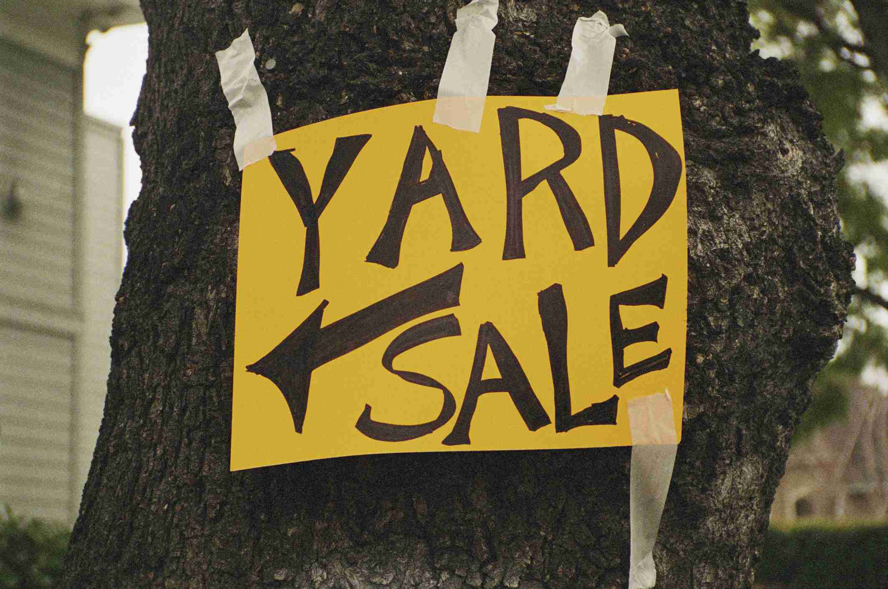***

***HOA Dues***

Homeowners can now pay association dues with credit cards if they wish.

Simply go to **www.univprop.com** and click on pay credit card payment and follow the link.

Visa, Master Card, American Express and Discover Card may be used.

If the homeowner does use the credit card there is a 5% convenience fee the homeowner is charged.

***Lake Heron Contact Information*:**

***Property Manager*** - Angela Hester

University Properties Inc. 813-980-1000

or email her at... ahester@univprop.com

***Website* -** Univprop.com - HOA# "4350"

***Volunteers* *Name***

**Board (President) Sam Gray**

**Board (VP) Max Saus**

**Board (Secretary) Ron Bowman**

**Board (Treasurer) Cyndie Smith**

**Board (Director A.L.) Mike Flanagan**

**Park**

Ron & Lori Bowman Kathy & Sam Gray

Pam Schwebl Ruth Copeland

Don Bushkie Linn Torres

Bonnie Mikulla Maxine Pickert

Susan Hoelseggen Lee Carter

Pam Kelly Sheila King

**Social Committee**

Sheryl and Ron Spencer Cyndie and Bram Smith

**Newsletter Delivery**

Vickie Morris Beverly Patterson

Betsy Nehr Sherry Williamson

John Copeland Maria Saldarriaga

Hoke Cash

**Newsletter** Dee Ryder

**Grounds**

Don Bushkie Ruth Copeland (Irrigation)

**Architectural Control** Pam Kelley (Chairperson)

Matt Boisvert

Rachel Powers

Bill Prall

**Finance**

Kathy Gray Cyndie Smith

John Copeland

**RV Park**

Max Saus (Chairperson) Larry Kelly   
Hoke Cash

**Community Center**

Ed Martinell

John Copeland

**Wright Termite & Pest Control - 813-948-0229**