***Volume 21 – Issue 6***

***2023 Board of Directors:***

**President - *Max Saus***

**V. President - *Ron Bowman***

**Treasurer - *Tiffany Wells***

**Secretary - *Mark Cravens*  
Director at Large *- Linn Torres***

an02097_

The Lake Heron" Banner"

*Lake Heron is a welcoming, caring, vibrant and well managed community we call home.*

|  |
| --- |
| **Screenshot 2023-05-30 163150.jpg**  **\*\*\*\*\*\*\*\*\*\*\*\*\*\*\*\*\*\*\*\*\*\*\*\*\***  Email your articles for the next issue to  Dee Ryder at **Dee\_Ryder@Verizon.net**  put ***"For The Banner"*** in the Subject line *Please* …  Only emailed items will be accepted.  ***October Banner Deadline is Sept 25, 2023*** |

ite

Lake Heron HOA does not recommend nor endorse any advertisement printed in the Banner.



christmd

*Board*

*Meeting*

*will be on*

*June 12th, 2023*

*at 6:30 PM*

*in the Clubhouse*

***May Board Meeting***

The tennis courts are done and we are looking for upgrades to the chairs that are in the court. There are two tennis courts and up to three pickleball courts that can be set up for use. Do not forget the lights for night time use.

New lights have been added to our Lake Heron signs. Looking for someone to repaint those signs but that is not as easy as it sounds. Maybe we can find a university student at a more reasonable price then have been quoted so far. Will be adding lights to our pathway in the park for more night time safety and use.

There are a few projects that were approved that have yet to be started such as the landscape enhancement at Lake Floyd and Clubside, sidewalk repair with upgrades and reducing the number of peacocks in our area. Seems like every contractor has more work than they can handle.

The Finance Committee is going to find ways to move money around to pay for some ongoing and future expenses. Will also discuss which banks in our area that are best to invest some of our cash in CD’s.

I know we are not the A Team but I want to thank everyone who is helping me do a better job as president. Your hard work and dedication is what makes this a great community. See you at the next Board Meeting on June 12th at 6:30.

***~Max Saus - President***

***From the Cook’s Corner***

***Ham and Potatoes Casserole***

Really good if you have some leftover ham.﻿

3/4 cup chopped onion

1/4 cup chopped green pepper

2 tablespoons margarine

1 tablespoon flour

1 dash pepper

1 cup milk

1 cup shredded cheddar cheese

1/4 cup mayonnaise

3 cups potatoes, cooked and diced

2 cups ham, cooked and diced

**DIRECTIONS**

HEAT oven to 350 degrees.

COOK onion and green pepper in margarine until tender.

STIR in flour and pepper.

ADD milk and bring to a boil, stirring constantly.

REDUCE heat and add cheese and mayo; stir until cheese melts.

ADD potatoes and ham; put into casserole dish.

BAKE for 30 minutes.

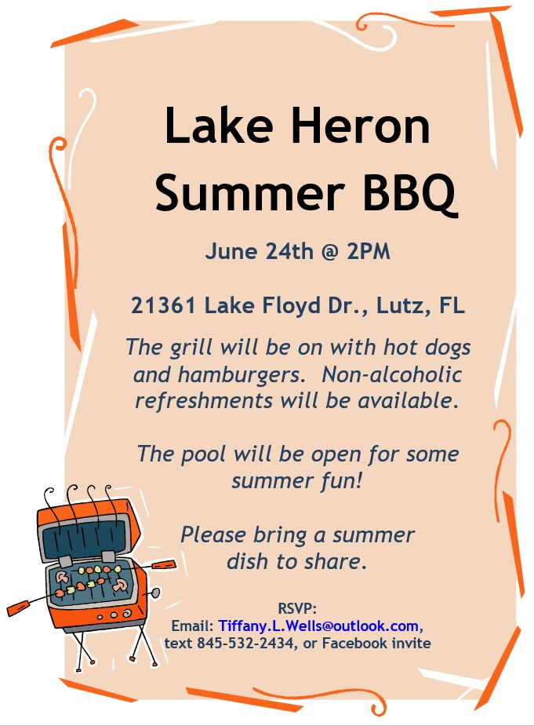

***Pickleball/Tennis Courts***

Our resurfacing is complete and **it looks great!** They put down the angular sand that wears longer, creates a hand trowel surface and plays slow to medium for tennis. The vendor came highly recommended and responded well to our requests.

So much work was needed due to deep cracks, separations and unlevel court surfaces. We hope you will get out and enjoy some tennis and pickleball now. Some have asked about the lines and what do we have available. I’ll attempt to answer those questions.

1. We have two tennis courts with new tennis nets.
2. We have two pickleball courts utilizing the same two new tennis nets on the tennis courts.
3. We have an OPTION NOW. Instead of using the tennis net of the court near the mailboxes for just one pickleball court, we can bring our own portable nets and set up two pickleball courts on that tennis/pickleball court. In other words, depending on demand, we can either play pickleball on two courts using the tennis nets or play on three courts (using one tennis net by the pool court and two temporary pickleball nets by the mailbox court).

We are discussing putting on a free pickleball clinic for new players, intermediate and advanced players. If you are interested, would you email me at lheronsecretary@gmail.com ? We will follow up with a discussion on a date/time. Also, we could use some advanced players to help demonstrate skills, that way we all improve our games and have more interaction amongst our community!!

***~Mark Cravens, Secretary Lake Heron HOA***

***GET READY !!***

***Annual Yard Sale*** will be Nov. 11th

Start gathering up your goodies for the upcoming Fall sale

***SAVE THE DATE***

**MINUTES**

**Lake Heron HOA, Board Meeting**

**May 17, 2023**

Call to order: 6:30 PM Clubhouse and combined Zoom.

Present at the meeting: Max Saus, Ron Bowman (via Zoom),Tiffany Wells, Mark Cravens, Linn Torres and ACC members- Rachel Powers and Vickie Morris.

Proof of Due Notice Posted: 48 Hrs. Yes.

**Solar Panel and Energy Saving Device Standard reviewed**

Finance- Max Saus asked John Copeland to report on reserve funds and CDs. Fin. Committee recommended $250,000 be moved from reserve to cash accounts to be placed in a CD. Balance would be approximately $300,000 in reserves. Max motioned, Tiffany 2nd and unanimous vote. Finance committee to report recommendation.

Treasurer- Tiffany Wells, 2022 P&L for April not available yet. The budget for March was $23,752.35, we spent $25,990.94 with a difference of -$2238.59.

Grounds/Irrigation- Ruth Copeland, timers are being installed and adjusted common areas after the storm.

Architectural Control- Rachael Powers, nothing new.

Clubhouse- Angela with UPI. 2 reservations in May. No other items.

RV Parking- Max Saus. 1 open spot available for rent. No problems.

The Park Team- Linn Torres- water sprinkler off until timer replaced/repaired. Paver meeting upcoming with vendor.

Parking Enforcement-Linn Torres. Snowy Egret parking problems. Helpers needed for parking enforcement. Contact Linn.

Social Committee- Tiffany Wells. Town Hall meeting-28 attended and would like it to be bi-annual. Kentucky Derby night-27 attended. June 24th is Barbeque night. Time T.B.D.

Welcome Committee- Tiffany Wells. New owner meeting on Lake Heron. New Tenant coming on Woodstork.

**Old Business:**

Entrance sign lights. solar units completed.

Tennis court resurfacing. Completed. Final payment being made.

Hedge/temporary fence by tree on Lake Floyd. Motion by Linn to Fence by compost was painted by John Copeland. New sign coming.

Landscape for 6 bushes and sprinkler system $360 with Green Bandit. Motion made to install. Max motion, Tiffany 2nd, Unanimous.

Motion to rescind February’s motion to move $2,000 from the Special Project account  to the Miscellaneous account.  The motion was made by the Finance Committee. Unanimous vote.

**New Business:**

Timer in the park being redone by Green Bandit for water sprinklers.

3 Entrance sign painting bids needed. Mark is getting bids.

Suggestion/reminder in the banner that solar requires ACC approval.

Revised Standard for Energy Saving Devices (solar, etc.)-still needs revision with ACC. Meeting with ACC TBD

Approve peacock removal at a price not to exceed $6,000. Max motion, Linn 2nd, passed 4 to 1. Ron voted no.

Peacock removal discussion for funding the project- finance committee said $6,000 can come from the Retained Earnings Account.

Neighborhood comments from the Floor after the meeting:

Resident-Sprinklers are turning on along Aaron Court, the park area and some other homes during the day (Green Bandit is addressing timers after the power outage).

Resident-Lake Level is low. Covered gazebo cross braces appear to need repair and staining.

Resident- pool cleaning, condition, water levels and increased cost. Perhaps resident volunteers needed to help address with the pool company.

Discussion to clarify parliamentary procedure that HOA boards must follow for the board to discuss matters on the agenda was presented before the official meeting to attendees by Mark Cravens, then to open for resident questions, concerns and input at the end, during the designated 15 minutes. Also, residents can submit items to discuss in future meetings to our UPI Property Manager, Angela Hester, at [ahester@univprop.com](mailto:ahester@univprop.com).

Adjournment at 7:28 p.m.

Next Meeting: June 12, 2023

***The staff of the Banner is taking their usual summer time off.***

***A bit different this summer as it will be July, Aug and September.***

***We will be back as usual in October.***

***RV Park Rentals***

We have an opening in the Lake Heron RV Park. Our RV Park is in a locked and fenced area next to Aaron Court. Use of the park is limited to residents of Lake Heron and the Hammocks. To keep the expenses down, volunteers manage and maintain the park. All rentals have to have wheels so they can be moved, no sheds. The price is $1.50 per foot per month. You will get one month free if you rent for a year.

You can contact me at 948-4538 or Larry Kelly at 758-4503. Do leave a message with your phone number.

***~Max Saus***

***Garbage and Recycling***

If you recycle, you ***CAN NOT*** use any bags.

You ***MUST*** use a dedicated container (tub or can).

***The Recycling will be picked up every Wednesday,***

***usually before 7am***

The truck crews will pass by any container that has plastic bags.

We see more and more bags being left out for curbside pick up, and those bags are being ignored.

Your recycle container should have a “Recycle Sticker” on it.

The stickers can be obtained by calling **727-856-4539**.

***Reminder – When Home or Away***

You can still get The Banner and keep up with Lake Heron news by accessing the Lake Heron website.

Access to Lake Heron Web Page

1. Type into your internet search page **“univprop.com”**
2. Locate **“Association Pages”** in the contents list in the left border
3. Lake Heron’s number is 4350. Put your mouse in the number list and scroll down to 4350 and click on it.
4. The website will now open with the calendar of events for the clubhouse.  To reach other pages just scroll down (or Page Down).

On our web page you’ll find copies of The Banner, Board Minutes, Directors and committee Chairpersons. Our standardized forms in printable copies are on the web page.

***Information To Set Up Zoom For Lake Heron Meetings***

In order to attend the Zoom meeting you will need to download the [Zoom.us](http://zoom.us/) app by going to [www.zoom.us/download](http://www.zoom.us/download) and click to sign up. You will need a camera and a microphone on your computer in order to participate. On the scheduled date and time of the meeting you would click on join a meeting and you will be asked for the following information in order to be a part of the meeting:

**MEETING ID: 219 022 5906    /     PASSCODE:  2020**

**Thinking of putting in SOLAR?**

Remember, you need to contact the ACC committee

and Angela Hester with UPI for forms, approvals and standards.

You can see the standards at:

https://www.univprop.com/resources/association-pages/hoa-4350/

***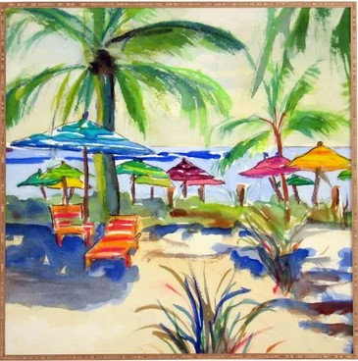***

***HOA Dues***

Homeowners can now pay association dues with credit cards if they wish.

Simply go to **www.univprop.com** and click on pay credit card payment and follow the link.

Visa, Master Card, American Express and Discover Card may be used.

If the homeowner does use the credit card there is a 5% convenience fee the homeowner is charged.

***Lake Heron Contact Information*:**

***Property Manager*** - **Angela Hester**

**University Properties Inc. 813-980-1000**

**or email her at... ahester@univprop.com**

***Website* -** Univprop.com - HOA# "4350"

***Volunteers* *Name***

**Board (President) Max Saus (813-948-4538)**

**Board (V. President) Ron Bowman**

**Board (Treasurer) Tiffany Wells(845-532-2434; Tiffany.L.Wells@outlook.com)**

**Board (Secretary) Mark Cravens(813-361-0399; Lheronsecretary@gmail.com)**

**Board (Director A. L.) Linn Torres**

***Park***

Linn Torres - Chairperson Rachel Powers

Ruth Copeland Kathy & Sam Gray

Linda Brunner Lee Carter

Don Bushkie Pam Schwebl

Bonnie Mikulla Maxine Pickert

Sheila King Max Saus

Beatriz Patino Barb Charvat

Mike Flanagan Bill & Jennifer Prall

Mark & Jill Cravens Julie & Campbell Buchanan

***Social Committee***

Tiffany Wells - Chairperson

Mark and Jill Cravens

***Newsletter Delivery***

Vickie Morris Beverly Patterson

Olivia & Tiffany Wells Sherry Williamson

John Copeland Maria Saldarriaga

Hoke Cash Robert Spaulding

***Newsletter Editor*** Dee Ryder

***Welcome Committee***

Tiffany Wells-Chairperson Michael Flanagan

***Grounds and Irrigation***

**UPI (Angela Hester) 813-980-1000**

Ruth Copeland

***Architectural Control***

Rachel Powers - Chairperson Vickie Morris

Bill Prall

***RV Park***

Max Saus - Chairperson Larry Kelly   
Hoke Cash

***Community Center and Courts***

**UPI (Angela Hester) 813-980-1000**

***Wright Termite & Pest Control* - 813-948-0229**